# Tomcat 1

## Install Java

Check if java is installed and/or version number by running **java –version** in a command prompt.

We are after version 8 of java, it is often referred to as 1.8 (similarly java 7 is called 1.7). If java is not installed download the latest version from <http://www.oracle.com/technetwork/java/javase/downloads/jre8-downloads-2133155.html>

For Windows servers this will normally be **Windows x64** (executable)

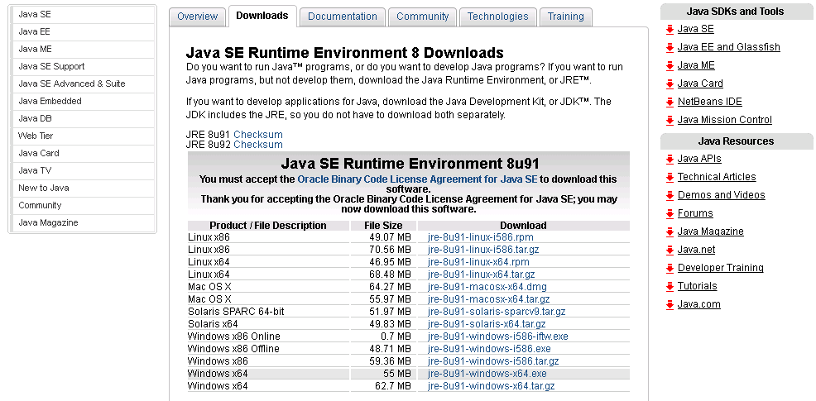

Change the destination folder for the install to **C:\Program Files\Java\jre1.8**

|  |  |
| --- | --- |
|  |  |

## Apache Tomcat 8

Download Tomcat from <http://tomcat.apache.org/download-80.cgi> The *32-bit/64-bit Windows Service Installer* should work for most systems.

On the component screen deselect Documentation and on the Configuration screen:

* Rename the Windows Service Name – e.g. ABCTomcat8 (where ABC is the short name for the trust)
* Select Create Shortcut for all users
* Enter name and password for the Administrator Login

|  |  |
| --- | --- |
|  |  |

The Java Virtual Machine should be **C:\Program Files\Java\jre1.8** (the folder where we installed java) and accept the defaults for the install directory.

Apache Tomcat should now be running. Check the install by browsing to <http://localhost:8080/>

## Removing Web Apps

Log onto the Manager App by selecting **Manager App**, when prompted enter the Tomcat Administrator username and password you set up earlier.

Removing a Web App is simple. Click on the Undeploy option next to the app you wish to remove. We don’t need the root app **/** (the welcome screen) – so go ahead and remove that.

|  |  |
| --- | --- |
|  |  |

## Installing a Web App 1

The manager app can also be used to deploy apps that are under 50 Meg.

Firstly download a sample app. In this example we will use hawtio which a web frontend for a number of java apps. The web app can be found at <http://hawt.io/getstarted/index.html>

Download the **hawtio-default.war** (java web applications have a war extension, the war file is essentially a zip file with a war extension)

|  |  |
| --- | --- |
|  |  |

Now go back into the Tomcat Manager App (<http://localhost:8080/manager/html>) and click on **Select WAR file to upload**, pick the hawtio.war (or hawtio-default-1.4.65.war) you just downloaded and then click on Deploy.

|  |  |
| --- | --- |
|  |  |

Hawtio will now be listed under the applications. You can try hawtio by clicking on the link.

|  |  |
| --- | --- |
|  |  |

## Tomcat Folder Layout – Install Web App 2

The three main folders are shown below (in windows explorer browse to **C:\Program Files\Apache Software Foundation\Tomcat 8.0**). We will cover the **conf** folder in the next tutorial where we secure the Tomcat application server.

|  |  |
| --- | --- |
|  | Configuration Folder |
| Log Files |
| Web Applications |
|  |

As mentioned in the previous section we can’t deploy large war files (over 50Meg) via the Manager App. In this case we use an alternative which is to copy the war file directly into the **webapps** folder.

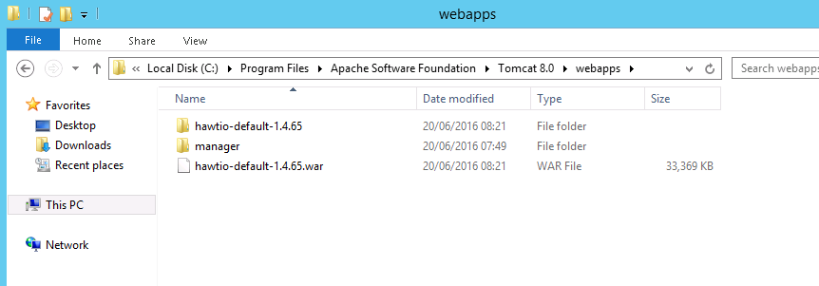

When we upload a file via the Manager App it is stored in this location. When the app is uploaded or copied, Tomcat unzips the file into a folder and installs the App. The WAR file can be removed once the App is installed.

## Administration

Tomcat can be configured, stopped and started via the Configuration App.

|  |  |
| --- | --- |
|  |  |

The General tab gives you options to stop and start Tomcat and also Start Up type. These same options (and the Log On tab) are also available in **Services**

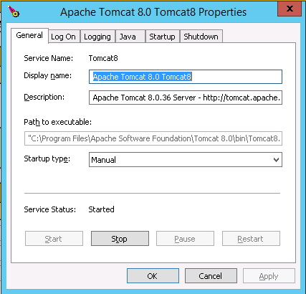

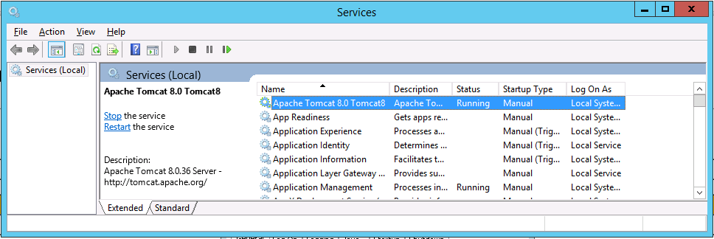

We have installed Tomcat with default settings and the memory allocation is not adequate for our purposes. We can increase this by changing the JVM settings. Change the Initial memory pool and Maximum memory pool to 1024 (we use the same value to have a more efficient garbage collection setting)

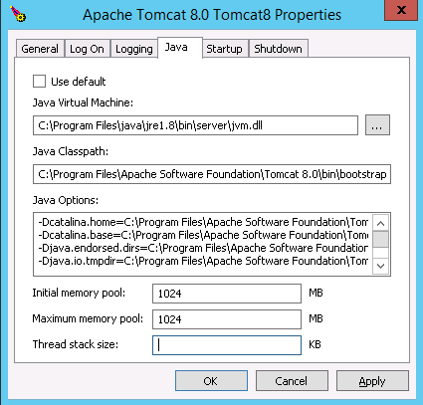

Go back to the General tab and restart tomcat.

## Next Tutorial

* Configuring Tomcat
* Securing Tomcat
* Configuring Web Application